Artificial Intelligence and Machine Learning
Project Documentation format
1. Introduction
• Project Title: Electric Motor Temperature Prediction using Machine Learning• Team Members: List team members and their roles.
2. Project Overview
• Purpose: The purpose of this project is to develop a Machine Learning-based predictive maintenance system that predicts electric motor temperature in advance. This helps industries prevent overheating, reduce downtime, and minimize maintenance costs.
Features:
- Motor dataset input handling
- Data preprocessing and feature engineering
- Regression model training
- Temperature prediction
- Alert generation system
- Performance evaluation

3. Architecture
Frontend:
The frontend consists of a simple user interface (Jupyter Notebook / Web Interface) that displays predicted motor temperature and alert notifications.
Backend:
The backend handles data preprocessing, feature engineering, and machine learning model execution using Python.
Database:
Motor dataset is stored in CSV format. Trained model files are stored locally in .pkl format.
4. Setup Instructions
Prerequisites:
- Python 3.x
- Jupyter Notebook / VS Code
- Required libraries (Pandas, NumPy, Scikit-learn, Matplotlib)
Installation:
- Install Python
- Install required libraries using:
pip install pandas numpy scikit-learn matplotlib
- Open project folder
- Run the notebook or Python script
5. Folder Structure
Project Folder Structure:
- dataset/ (Motor CSV dataset)
- model/ (Trained model file .pkl)
- notebook/ (Model training notebook)
- screenshots/ (Output screenshots)
- documentation/ (Project reports)
6. Running the Application
- Open terminal in project folder
- Run Jupyter Notebook
- Execute model training cells
- Run prediction section
OR
Run Python script using:
python main.py
7. API Documentation
Not Applicable (Local Machine Learning Project)
If deployed as API, endpoints would include:
POST /predict – Predict motor temperature
GET /model-performance – Get model metrics
8. Authentication
Not Applicable (Local academic project).
If deployed in production, authentication can be implemented using token-based access control.
9. User Interface
The user interface displays:
- Predicted motor temperature
- Model performance metrics
- Alert messages when threshold exceeds
10. Testing
The system was tested for:
- Dataset validation
- Model training accuracy
- Prediction accuracy
- Alert functionality
- Performance under multiple inputs
11. Screenshots / Demo
- Model training output
- Prediction result
- Alert generation
- Evaluation metrics
- 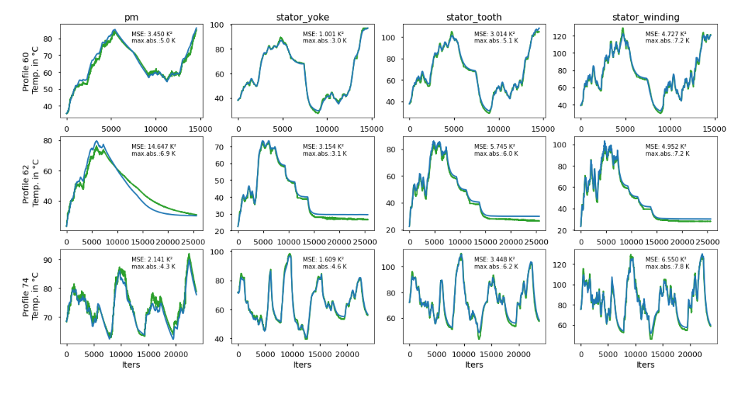

12. Known Issues
- Performance may vary with extremely large datasets
- Model requires retraining for different motor types

13. Future Enhancements
- Cloud deployment
- Real-time IoT sensor integration
- Dashboard with live monitoring
- Support for multiple motor types
- Advanced deep learning models

